**Customer Relationship of Pilates Circuit**

Submitted by:

Submitted to:

Dated:

**Customer Relationship of Pilates Circuit**

**Context of the Organization**

In general, Pilates Circuit works in the health and fitness industry and offers a large variety of Pilates classes that are customized to suit the different needs and fitness levels. Some of their services include reformer Pilates, beginners’ reformer Pilates, cardio reformer Pilates, one-on-one sessions, mat Pilates, and advanced Pilates. Actually, the aim of these offerings is concerned with accommodating everyone from fitness lovers who are looking for a challenge to beginners who are trying Pilates for the first time. The organization has four studio locations in West London including Wandsworth, Fulham, South Kensington, and Wimbledon where convenient access is offered to their customers, which helps in promoting an approach that focuses on customers to fitness (Pilates Circuit, 2024).

It should be noted that the value Pilates Circuit offers lies in its focus on improving the physical health and mental well-being, and the lifestyle of customers. The studio promotes not just fitness but also personal growth and inclusivity. Through personalized classes and an environment that is supportive, Pilates Circuit helps people in improving mindfulness and flexibility. In this paper, the focus is on the evaluation of the CRM or customer relationship management of Pilates Circuit and the recommendations that can be considered for improving the engagement and retention of customers.

**Customer Insights and Experience**

Typically, Pilates Circuit offers services to a large number of customers including young professionals, working women, mothers, and people who are looking for fitness solutions that are low-impact.

**Psychographic Insights:** The business targets and focuses on customers who prefer health and wellness, and even community. Most customers are socially conscious and like sustainability and their lifestyles often focus on self-improvement and having a balance between work and personal life (Kumar & Reinartz, 2018).

**Behavioral Insights:** The brand focuses on customers who range from regular attendees to participants who are occasional and newcomers. The levels of engagement vary with some people highly involved in the community of Pilates, while others have medium or low participation. Their behaviors regarding purchasing also differ as some have memberships while other have add-ons and trial classes.

**Demographic Insights:** In the case of demographics, customers belong to a number of age groups including 18-24-year-old students and young professionals. The brand also targets 25-34-year-old working women and 35-44-year-old people in different leadership roles. Typically, women aged 45 and above often look for Pilates for health maintenance or recovery (Buttle & Maklan, 2019). Levels of income tend to range from lower-middle to high-income groups, which shows the focus of Pilates Circuit on inclusivity.

It is important to note that the customer experience at Pilates Circuit involves a number of digital and physical touchpoints. For example, it all starts with a welcome email that people get upon joining and the brand maintains a presence across different online platforms such as Instagram, its website, an application, and even email marketing. However, its work on social media is not really consistent as its Twitter and Facebook accounts are not really activity. In its four studios, it should be noted that interactions that are non-digital take place, which offers a community-driven and personalized experience.

**Customer Value**

Pilates Circuit creates customer value by addressing their specific health and fitness goals. For regular customers, it offers tailored classes to maintain engagement. Beginners benefit from introductory classes, while advanced members enjoy more challenging sessions. By emphasizing community and inclusivity, the organization fosters a welcoming environment that encourages repeat visits and long-term loyalty (Payne & Frow, 2016). The Pilates Plus Perks program further enhances customer value, rewarding consistent attendance with free classes, exclusive events, and milestone incentives.

**Customer Relationship Program**

The customer relationship program of Pilates Circuit, which is Pilates Plus Perks has the aim of improving loyalty and engagement in the long run. The program offers different complimentary classes and rewards on milestones, and different birthday perks with the aim of making a sense of connection and appreciation among members of the program. However, there are areas where the program could be improved for maximizing its effectiveness. The program of Pilates Plus Perks is designed carefully for rewarding the loyalty of customers. After every ten sessions, there are free classes and different milestone incentives at the 50th and 100th sessions to help in improving the participation of customers. Moreover, the referral program is an effective way of attracting new customers while improving relationships with existing ones. The class on birthday celebrations and wellness sessions that are held quarterly help in adding a personal touch, which makes customers feel valued (Gil-Gomez, Guerola-Navarro, Oltra-Badenes, & Lozano-Quilis, 2020).

Even though the rewards are appealing, the program does not have tiered benefits that differentiate between attendees who are occasional and different customers who are loyal to the brand. Offering different levels of rewards on the basis of participation could motivate customers to increase their attendance. Moreover, there is no integration of digital touchpoints like the app or website for tracking rewards in a seamless. Actually, making it easier for customers to monitor their progress and redeem perks is missing and it could help in improving the accessibility of the program. The efforts of Pilates Circuit to make a customer journey that is seamless are apparent in their strategic objectives. The aim of the business to obtain new customers and retain existing ones, and engage different inactive clients again through personalized marketing and incentives.

In addition to it, the strategy of requiring customers to review their previous class before booking the next one is quite innovative because it collects feedback while encouraging attendance that is consistent. However, their social media accounts that are inactive and dependent on email communication affect and decrease their ability of fully engaging with customers in the digital environment (Paliouras & Siakas, 2017). Actually, regular updates on platforms such as Instagram, Facebook, and Twitter can help in improving customer connections and attracting a larger audience.

**Recommendations**

For helping Pilates Circuit in growing and keeping customers engaged, there are some simple and effective ways of improving how to obtain new customers:

1. **Improving Social Media Presence: P**osting on Instagram consistently and reopening accounts on Facebook and Twitter can make the brand more visible. In fact, sharing videos of classes and stores of customer success, and tips about fitness and wellness can be helpful in attracting new audiences. On social platforms, paid advertisements that focus on the right customer groups such as mothers looking for relieving stress and professionals conscious about health can also be helpful in bringing new customers.
2. **Offering a Free Campaign for First-Class: Typically, n**ew customers are more likely to try Pilates if there is no cost upfront that is experienced. Actually, having a campaign of “first class free” can motivate people to visit the studios. It should be noted that following up with different promotional emails that offer a discount on their next class or membership can help in turning people into loyal customers.
3. **Collaborating with Local Businesses:** Working with health and wellness businesses that are nearby such as juice bars or gyms, can help in attracting their customers. In fact, joint promotions or events such as wellness days can increase awareness about Pilates Circuit to a large number of people (Foltean, Trif, & Tuleu, 2019).
4. **Engaging Through Fitness Challenges:** Usually, running short challenges about fitness such as a “10 Classes in 30 Days” can be quite helpful. Promoting these through platforms such as email and social media, and offering prizes such as discounts or free classes to participants will help in obtaining new customers.

The following are some recommendations for improving the retention of customers:

1. **Making a Personalized Membership Plan:** The business should offer flexible memberships that suit different lifestyles. For example, the brand should make a plan for different occasional users (5-10 classes per month) and one for regulars (unlimited access). This flexibility makes sure that customers feel that they are paying for what they need.
2. **Improving Loyalty Rewards:** The program of Pilates Plus Perks should be made more engaging by adding some extra benefits, such as early access to new classes and benefits for members who reach different milestones such as 100 classes.
3. **Personalizing Class Recommendations:** Customer data should be used for recommending classes on the basis of their past preferences. For example, if someone attends cardio Pilates on a regular basis, related classes should be suggested or advanced sessions through the app or email should be suggested. Personalized suggestions can make customers feel quite cared for and more likely to stay engaged.
4. **Engaging with Inactive Customers:** Customers should be identified who have not attended in a while and recovery emails should be sent with special offers for bringing them back (Kumar & Reinartz, 2018). For example, a discounted bundle should be offered or a complimentary session can also be offered.

**Conclusion**

Overall, Pilates Circuit has made itself a fitness provider that focuses on the community and offers services that add value to the lives of people. The business meets the needs of customers effectively through its welcoming environment and a loyalty program that it maintains. However, there are opportunities for improving the program of customer relationships by introducing rewards that are tiered and restarting activity on social media among others. By focusing on these areas, Pilates Circuit can definitely improve customer loyalty and engagement, and even improve its position in the industry of health and fitness.

**References**

Buttle, F., & Maklan, S. (2019). *Customer relationship management: concepts and technologies.* Routledge.

Foltean, F. S., Trif, S. M., & Tuleu, D. L. (2019). Customer relationship management capabilities and social media technology use: Consequences on firm performance. *Journal of business research*, 563-575.

Gil-Gomez, H., Guerola-Navarro, V., Oltra-Badenes, R., & Lozano-Quilis, J. A. (2020). Customer relationship management: digital transformation and sustainable business model innovation. *Economic research-Ekonomska istraživanja, 33*(1), 2733-2750.

Kumar, V., & Reinartz, W. (2018). *Customer relationship management.* Springer-Verlag GmbH Germany, part of Springer Nature 2006, 2012, 2018.

Paliouras, K., & Siakas, K. V. (2017). Social customer relationship management. *International Journal of Entrepreneurial Knowledge, 5*(1).

Payne, A., & Frow, P. (2016). Customer relationship management: Strategy and implementation. In *The Marketing Book* (pp. 439-466). Routledge.

Pilates Circuit. (2024). *PILATES CIRCUIT: Dynamic and Contemporary Reformer Pilates Group Fitness Classes*. Retrieved 2024, from https://www.pilatescircuit.co.uk/

**Appendix**

**Insufficient Followers on Instagram**

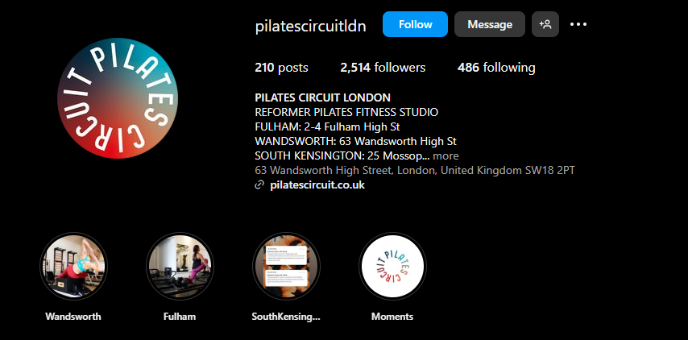

**Insufficient Followers on Facebook**

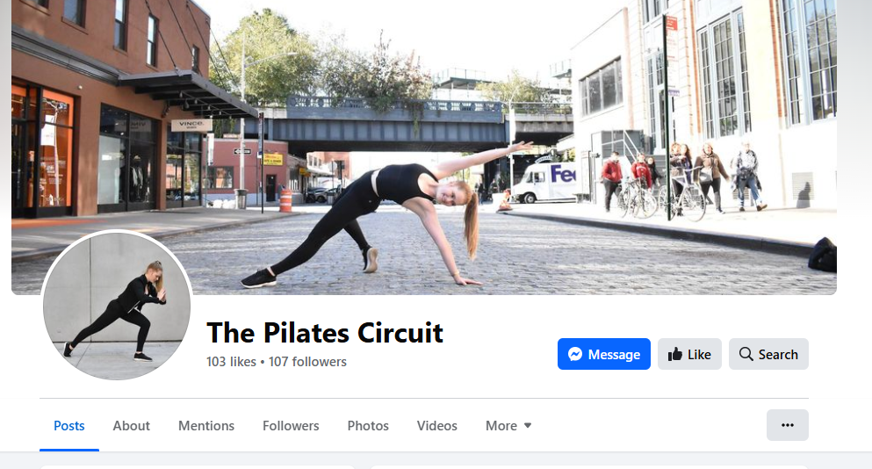

**Inconsistent Posting**

